**Power BI Assignment 1**

Question:1 What do you mean by BI? Explain.

**Solution:**

Business intelligence (BI) combines business analytics, data mining, data visualization, data tools and infrastructure, and best practices to help organizations to make more data-driven decisions.

Businesses and organizations have questions and goals. To answer these questions and track performance against these goals, they gather the necessary data, analyze it, and determine which actions to take to reach their goals.

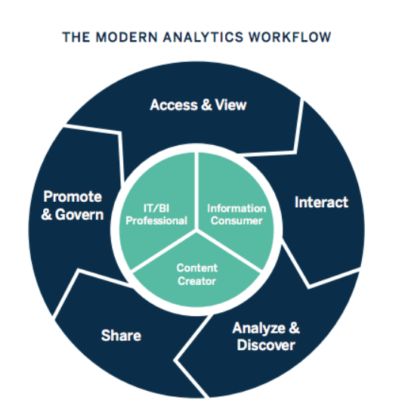

Question:2 How Power-BI helps in BI, and how does it help Analysts? Explain.

**Solution:**

**“**Power BI” “is a business analytics solution that lets you visualize your data and share insights across your organization, or embed them in your app or website.” The solution comprises several products and services, and value and versatility comes from leveraging the individual elements, and taking advantage of how they work together.

In Power BI Desktop, Analysts can:

* Connect to data
* Transform and model the data
* Create charts and graphs
* Create reports and dashboards that are collections of visuals
* Share reports with others using the Power BI service

Question:3 Explain Descriptive analytics?

**Solution:**

Descriptive Analytics is the examination of data or content, usually manually performed, to answer the question “What happened?” (or What is happening?), characterized by traditional business intelligence (BI) and visualizations such as pie charts, bar charts, line graphs, tables, or generated narratives.

Question:4 Explain Predictive analytics?

**Solution:**

Predictive analytics is the use of data, statistical algorithms and machine learning techniques to identify the likelihood of future outcomes based on historical data. The goal is to go beyond knowing what has happened to providing a best assessment of what will happen in the future.

Question:5 Explain perspective analytics?

**Solution:**

Prescriptive analytics is a type of data analytics—the use of technology to help businesses make better decisions through the analysis of raw data. Specifically, prescriptive analytics factors information about possible situations or scenarios, available resources, past performance, and current performance, and suggests a course of action or strategy. It can be used to make decisions on any time horizon, from immediate to long term.

Question:6 Write five real-life questions that PowerBi can solve.

**Solution:**

Five real-life questions that PowerBi can solve are:

* Waiting on Figures
* Using Data from Old Reports
* Excessive time spent preparing for presentations
* Being unable to find specific data sets
* Not being able to determine your level of success

Reference: <https://www.kizan.com/blog/top-5-challenges-solved-by-power-bi>